Software Engineering
Module 5
3 Marks :
1. ISO 9000 Standards and Software Quality Improvement
Definition:
ISO 9000 is a set of international standards ensuring quality management and consistency in software processes.
Key Points:
- Promotes standardization and documentation of processes.
- Encourages continuous improvement.
- Improves customer satisfaction through reliable software quality.
2. Five Levels of Capability Maturity Model (CMM)
Definition:
CMM defines five stages of software process maturity to improve process quality and efficiency.
Key Points:
- Initial: Ad hoc and chaotic processes.
- Repeatable: Basic project management established.
- Defined: Standardized processes across projects.
- Managed: Quantitative quality goals set and measured.
- Optimizing: Continuous process improvement.
3. Need for Project Software in Project Management
Definition:
Project management software helps plan, organize, track, and manage software projects effectively.
Key Points:
- Helps schedule tasks and allocate resources.
- Tracks progress and deadlines.
- Reduces project risks and chances of failure.
4. Estimation of Software Size
Definition:
Software size estimation measures the scope of the project to predict effort, cost, and time.
Key Points:
- Techniques: Lines of Code (LOC), Function Point Analysis (FPA).
- Helps in project scheduling and budgeting.
- Reduces risk of under or overestimation.
5. Steps in Risk Mitigation, Monitoring, and Management
Definition:
This plan helps identify, minimize, and monitor risks during the software project life cycle.
Key Points:
- Identify possible risks.
- Analyze impact and likelihood.
- Develop mitigation strategies.
- Monitor and update regularly.
6. Earned Value Analysis (EVA)
Definition:
EVA measures project performance by comparing planned work with completed work.
Key Points:
- Uses metrics: Planned Value (PV), Earned Value (EV), Actual Cost (AC).
- Helps control cost and schedule deviations.
- Improves decision-making during project tracking.
7. Network Scheduling Diagram
Definition:
A visual representation of project tasks and their dependencies.
Key Points:
- Components: Nodes (tasks), Arrows (dependencies), Critical Path.
- Helps identify sequence and timing of tasks.
- Useful for effective project planning and resource allocation.
8. Function Point Analysis vs LOC Estimation
Definition:
Two techniques for estimating software size and effort.
Key Points:
- FPA: Based on user functionality (language-independent).
- LOC: Based on total lines of code (language-dependent).
- FPA is more accurate for comparing productivity across projects.
Or,
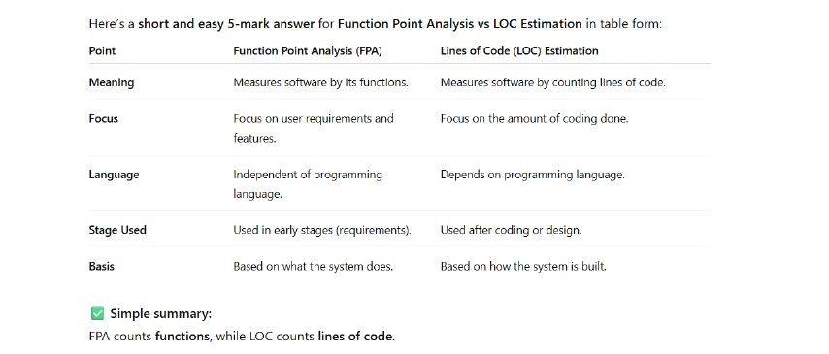
9. Verification vs Validation
Definition:
Both are testing techniques for ensuring software quality.
Key Points:
- Verification: Checks if product is built right (e.g., code review).
- Validation: Checks if product is right for the user (e.g., user testing).
- Together ensure correctness and usability.
Or,
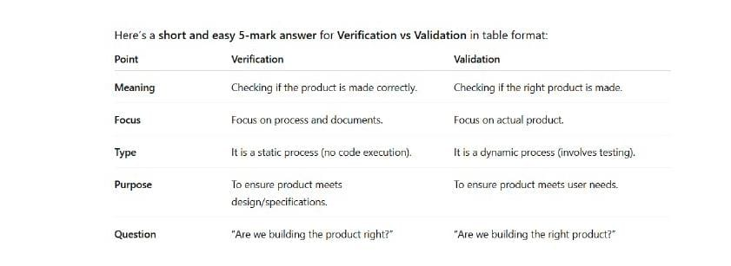
10. Significance of Quality Assurance (QA)
Definition:
QA ensures the software meets defined standards and performs reliably.
Key Points:
- Focuses on process improvement, not just testing.
- Prevents defects instead of detecting them later.
- Ensures customer satisfaction and maintainability.
11. Gantt Chart for Software Project Schedule
Definition:
A Gantt chart visually represents project activities along a timeline.
Key Points:
- Shows start & end dates for each task.
- Indicates dependencies and progress.
- Helps track milestones efficiently.
Or,
Gantt Chart for Software Project Schedule

A Gantt Chart is a bar chart that shows project tasks and their timelines to help plan and track a software project.

Key Points (1-line each):

Task List: Shows all project tasks in order.

Time Schedule: Displays start and end dates for each task.

Task Duration: Horizontal bars show how long each task takes.

Dependencies: Indicates which tasks depend on others.

Progress Tracking: Helps monitor completed and pending work.

Clear Planning: Makes project scheduling easy to understand.
12. Risk Management Plan for E-Learning Platform
Definition:
A strategy to handle risks in developing and maintaining an e-learning platform.
Key Points:
- Identify risks: data loss, server downtime, security threats.
- Plan mitigation: regular backups, security audits, cloud monitoring.
- Continuous review ensures reliability.
13. Purpose of Regression Testing
Definition:
Regression testing ensures that recent code changes don’t affect existing functionality.
Key Points:
- Performed after bug fixes or updates.
- Maintains system stability.
- Prevents introduction of new defects.
14. Project Schedule for Mobile App
Definition:
A structured timeline detailing tasks for mobile app development.
Key Points:
- Phases: Requirement → Design → Development → Testing → Deployment.
- Use tools like Gantt charts or Agile boards.
- Helps track progress and meet deadlines.
5 Marks :
1. Comprehensive Testing Framework (Verification & Validation)
Definition:
A testing framework that combines verification and validation ensures the software meets both specifications and user needs.
Key Points:
- Verification: Reviews, inspections, walkthroughs to ensure correctness of process.
- Validation: Unit, integration, system, and acceptance testing.
- Ensures software quality, reliability, and user satisfaction.
2. Project Plan for Restaurant POS System
Definition:
A project plan defines objectives, scope, resources, cost, and schedule for building a Restaurant POS system.
Key Points:
- Scope: Billing, order management, inventory, and reporting.
- Cost Estimate: Based on staff effort, tools, and maintenance.
- Schedule: Gantt chart for phases — design to deployment.
- Risk Plan: Backup systems, data security, and training risks.
3. Cost Estimation Using Function Point Analysis (FPA)
Definition:
FPA measures the software’s functionality from a user’s perspective to estimate cost and effort.
Key Points:
- Identify inputs, outputs, files, inquiries, and interfaces.
- Assign weights → Compute Unadjusted Function Points (UFP).
- Apply complexity and cost factors → Estimate total effort/cost.
4. Comprehensive Risk Management Plan
Definition:
A structured plan to identify, assess, and minimize project risks.
Key Points:
- Steps: Identify → Analyze → Prioritize → Mitigate → Monitor.
- Includes risk probability and impact matrix.
- Ensures project stability and goal achievement.
5. Framework Using RMMM Methodology
Definition:
RMMM (Risk Mitigation, Monitoring, and Management) minimizes project uncertainties.
Key Points:
- Mitigation: Define preventive measures.
- Monitoring: Track risk triggers.
- Management: Apply contingency actions.
- Ensures proactive handling of project risks.
6. Test Case Methodology for Maximum Defect Detection
Definition:
A structured process for writing and executing test cases to uncover defects efficiently.
Key Points:
- Design clear test cases with input, process, expected output.
- Use Boundary Value Analysis, Equivalence Partitioning, and Regression Tests.
- Prioritize critical modules for early testing.
7. Project Scheduling with Network Scheduling Techniques
Definition:
Network scheduling visually represents task dependencies and timing for efficient project control.
Key Points:
- Techniques: PERT (Program Evaluation and Review Technique), CPM (Critical Path Method).
- Identifies critical activities affecting project completion.
- Helps optimize resources and reduce delays.
8. Organizational Process Maturity Implementation Plan
Definition:
A structured plan to improve software process maturity for better quality.
Key Points:
- Based on CMM levels (Initial → Optimizing).
- Steps: Assess current maturity → Define goals → Implement process improvements.
- Ensures continuous improvement and quality culture.
9. Earned Value Analysis (EVA) & Performance Measurement Plan
Definition:
EVA evaluates project progress by comparing planned, earned, and actual values.
Key Points:
- Metrics: Planned Value (PV), Earned Value (EV), Actual Cost (AC).
- Derive Cost Performance Index (CPI) & Schedule Performance Index (SPI).
- Measures team efficiency and project health in real time.

